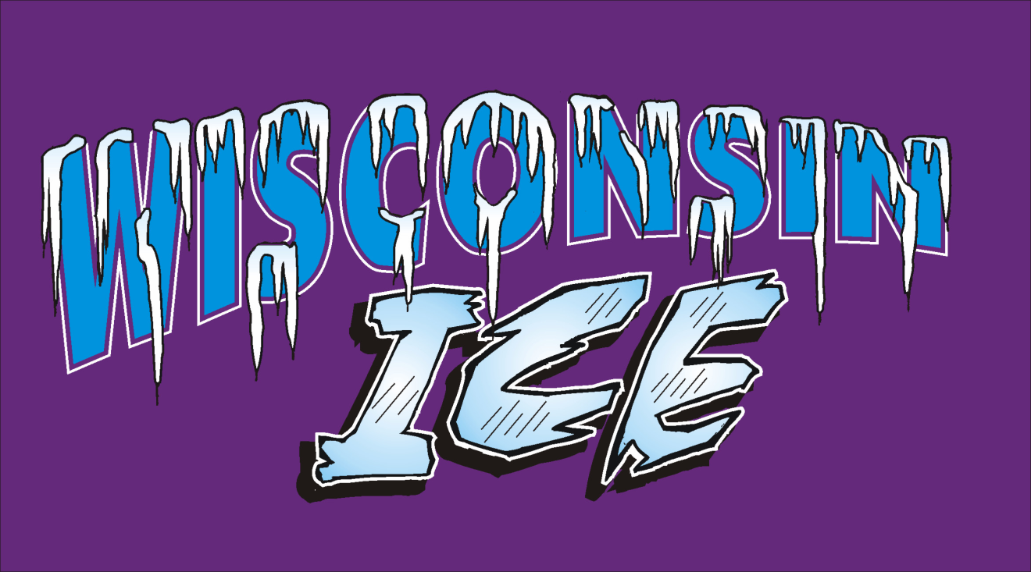
COACHES AGREEMENT
Related to Concussion Law WI Stat. 118.293

As a Coach it is important to recognize the signs, symptoms, and behaviors of concussions. By signing this form, you are stating that you understand the importance of recognizing and responding to concussions and head injuries per the guidelines set forth by the Department of Public Instruction and Statute 118.293.

Coaches Agreement:
I have read the Coaches Concussion and Head Injury Information and understand what a concussion is and how it may be caused. I also understand what the signs, symptoms, and behaviors are and agree to remove the athlete from practice/play if exhibited and/or a concussion is suspected.

I understand that it is my responsibility to inform the parents/guardian if I suspect a concussion or if a suspected concussion is reported to me and that the athlete cannot return to practice or play before providing me with written clearance from an appropriate health care provider.

I understand the possible consequences of the athlete returning to practice/play too soon.

Coach
Signature_ Date

Team Age & Level if Known at this Time _

Name

Date

Address

City Zip

County Phone_

Email

Have you had any concussion training? When/Where? _______________

