M a t e r i a l s a d a p t e d f r o m t h e U . S . DE PA R TM EN T O F HE A LT H A N D HU MA N SERV I CE S C EN TE R S F O R D I S E AS E C ON T R O L AN D P R EV EN T I O N

KNOW YOUR
CONCUSSION A B C s Assess Be alert for Contact a
the signs and health care situation symptoms provider
Wisconsin Concussion Fact Sheet for COACHES

THE FACTS
• A concussion is a brain injury.
• All concussions are serious.
• Most concussions occur without loss of consciousness.
• Concussions can occur in any sport.
• Recognition and proper management of concussions when they first occur can help prevent further injury or even death.

WHAT IS A CONCUSSION?

A concussion is an injury that changes how the cells in the brain normally work. A concussion is caused by a blow to the head or body that caused the brain to move rapidly inside the skull. Even a “ding,”
“getting your bell rung,” or what seems to be a mild bump or blow to the head can be serious. Concussions can also result from a fall or from players colliding with each other or stationary objects.

The potential for concussions is greatest in athletic environments where collisions are common. However, concussions may occur in any sport or recreational activity. As
many as 3.8 million sports-and recreation- related concussions occur in the United
States each year.
RECOGNIZING A POSSIBLE CONCUSSION

“When in doubt, hold them out”.

To help recognize a concussion, you should watch for the following two things among your athletes:

1. A forceful blow to the head or body that results in rapid movement of the head.

- and -

2. Any change in the athlete’s behavior,
judgment, or physical functioning. (See the signs and symptoms of concussion listed on the next page.)

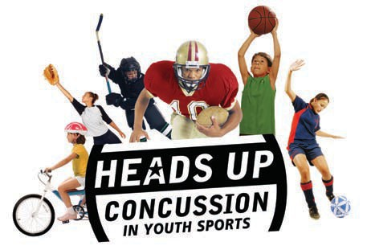
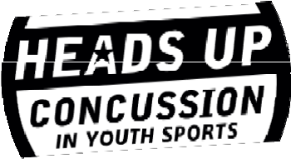





It’s better to miss one game than the whole season!

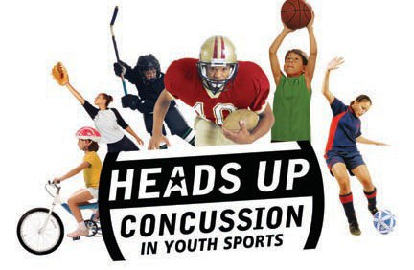
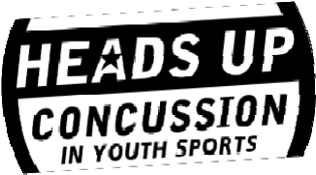
When in doubt, hold them out!

SIGNS OBSERVED BY COACHING STAFF SYMPTOMS REPORTED BY ATHLETE

• Appears dazed or stunned • Headache or “pressure” in head
• Is confused about assignment • Nausea or vomiting
or position • Balance problems or dizziness
• Forgets sports plays • Double or blurry vision
• Is unsure of game, score, or opponent • Sensitivity to light
• Moves clumsily • Sensitivity to noise
• Answers questions slowly • Feeling sluggish, hazy, foggy,
• Loses consciousness (even briefly) or groggy
• Shows behavior or personality • Concentration or memory problems changes • Confusion
• Does not feel “ right”

As an athletic coach it is your responsibility to remove an athlete from the youth athletic activity if you determine the athlete exhibits signs, symptoms, or behavior consistent with a concussion or head injury or if you suspect the athlete has sustained a concussion or head injury. The athlete then needs to be evaluated by a health care provider to determine if he/she sustained a concussion. An athlete who has been removed because of a determined or suspected concussion or head injury may not participate again until he/she is evaluated by a health care provider, is symptom free and has been provided written clearance to participate in the activity from a health care provider.
Wisconsin Act 172 defines a “health care provider” as a person whom all of the following apply:
1. He or she holds a credential that authorizes the person to provide health care.
2. He or she is trained and has experience in evaluating and managing pediatric concussions and head injuries.
3. He or she is practicing within the scope of his or her credential.
WI Stat. 118.293 defines “credential” to mean a license or certificate of certification issued by the state.
It is recommended that persons operating a youth athletic activity provide recommendations to athletes and parents about potential health care providers. http://docs.legis.wisconsin.gov/statutes/statutes/118/293

Prevention and Preparation

As a coach, you can play a key role in preventing concussions and responding to them properly when they occur. Here are some steps you can take to ensure the best outcome for your athletes and the team:

• Educate athletes and parents about concussion. At the beginning of each sports season for a youth athletic activity, distribute to each person who wishes to participate, a concussion and head injury information (such as) 1) ‘Know Your Concussion ABCs: A Fact Sheet for Parents’ and 2) ‘Know Your Concussion ABCs: A Fact Sheet for Athletes’. No person may participate in a youth athletic activity (practice or play) unless the person returns the ‘Parent/Athlete Agreement’ signed by the athlete and, if he or she is under the age of 19, by his or her parent or guardian. Exception: The pupil/parent has already received and signed a concussion and head injury information sheet for that school year (club- every 365 days).
Talk with athletes and their parents about the dangers and potential long-term consequences of concussion. Explain your concerns about concussion and your expectations of safe play to athletes, parents, and assistant coaches.
• Insist that safety comes first.
➢ Encourage athletes to practice good sportsmanship at all times.
➢ Make sure athletes wear the right protective equipment for their activity (such as helmets, padding, shin guards, and eye and mouth guards). Protective equipment should fit properly, be well maintained, and be worn consistently and correctly.

➢ Teach athletes safe playing techniques and encourage them to follow the rules of play.

Check with your youth athletic activity organizer about concussion guidelines and policies. Concussion policy and/or management plans can be developed to include commitment to safety, emergency procedures, and a ‘Return to Play’ procedures.

• Teach athletes and parents that it’s not smart to play with a concussion. Sometimes players and parents wrongly believe that it shows strength and courage to play injured. Discourage others from pressuring injured athletes to play. Know if players have ever had previous concussions. Never allow an athlete that has a confirmed or suspected concussion
to return to activity until symptom free and provided with written clearance from a health care provider.
Don’t let athletes persuade you they are fine.
• Prevent long-term problems. A repeat concussion that occurs before the brain recovers from the first can slow recovery or increase the likelihood of having long- term problems. In rare cases, repeat concussions can result in Second Impact Syndrome, which causes brain swelling,
permanent brain damage, and even death. This more serious condition is called second impact syndrome. Keep athletes with known or suspected concussion from play until they have been evaluated by a health care provider with experience in evaluating for concussion. Remind your athletes: “It’s better to miss one game than the whole season.”

ACTION PLAN

WHAT SHOULD A COACH DO WHEN A CONCUSSION IS SUSPECTED?

1. Remove the athlete from play. Look for the signs, symptoms, and behaviors of a concussion if your athlete has experienced a bump or blow to the head.

2. Ensure that the athlete is evaluated by a health care provider. Do not try to judge the severity of the injury yourself. Health care providers have a number of methods that they can use to assess if the athlete has sustained a concussion. As a coach, recording the following information can help health care providers in assessing the athlete after the injury:
• Cause of the injury and force of the hit or blow to the head
• Any loss of consciousness (passed out/ knocked out) and if so, for how long
• Any memory loss surrounding the injury
• What other symptoms the athlete experienced after the injury
• Number of previous concussions (if any)

3. Inform the athlete’s parents or guardians about the possible concussion. Make sure the injured athlete’s parent or guardian knows that the athlete is required be seen by a health care provider (as defined in WI Statute 118.293) if one is not available at the athletic event. Provide recommendations of potential health care providers in the area to the athlete, parents or guardian. Do not allow the athlete to be unsupervised at any time (return to the locker room or bus) if you suspect a concussion. Do not allow the athlete to drive home if you suspect a concussion.

4. An athlete who has been removed from any youth athletic activity because of a determined or suspected concussion or head injury may not participate again until he/she is evaluated by a health care provider, is symptom free and provides written clearance from a health care provider to return to activity.

It is recommended that coaches participate in additional Concussion/Head Injury Training such as: Free Concussion in Sports Course offered by NFHS:
Register at: http://www.nfhslearn.com/electiveDetail.aspx?courseID=15000
Course Objectives:
- Educate coaches, parents, officials, and students about concussions
- Identify the signs and symptoms of concussions
- Understand the problems associated with concussions
- Actions to take when a concussion is present
- Identify responsibilities of coaches, parents, officials, and students
The WIAA strongly encourages coaches at all levels to take this free course along with officials, parents and athletes so they have a better understanding of concussions and their effects on young, adolescent brain function.

